Experiment -9

AIM

Design tm to perform string comparison w= aba aba

PROCEDURE

1. Start the automata
2. Enter the states
3. Connect the respective nodes (states) and self loop.
4. Enter the inputs values in the named nodes .
5. Compile the execution with suitable inputs
6. Stop the executions.

Design input:

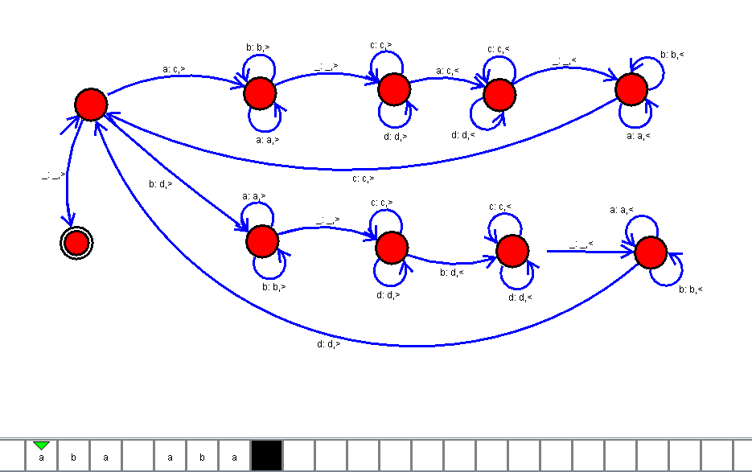

OUTPUT:

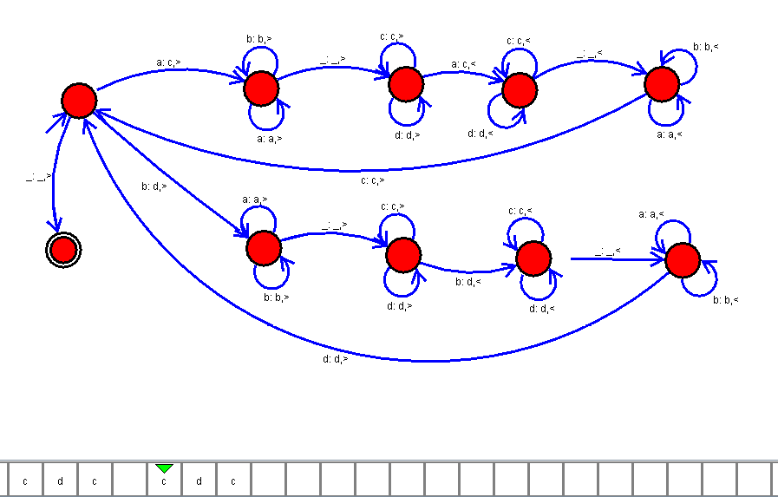

RESULT :

Thus the design of tm to perform string comparison has been implemented and executed successfully.